

**SSR COLLEGE OF ARTS, COMMERCE & SCIENCE**

**(Affiliated to Savitribai Phule Pune University)**

**Submitted to the partial fulfilment of**

**T.Y.B.Sc (Computer Science)**

**2017-2018**

**PROJECT WORK**

**Online Doctor Appointment**

**Guided by: Submitted by: KAVITA SAPTASAGAR 1. Himanshu P Bohra**

**2. Mayur Upadhayay**



**SSR COLLEGE OF ARTS, COMMERCE & SCIENCE**

**(Affiliated to Savitribai Phule Pune University)**

**Saily, Silvassa – 396230, D & N.H.**

***Department of Computer Science***

**C E R T I F I C A T E**

This is to certify that Mr. /Ms. _________________________________

Of T.Y.B.Sc. [Computer Science], Seat No.: __________ has completed project work in ___________________________________during the year 2017 – 2018.

In-charge H.O.D.

Internal External

Examiner Examiner Seal of the College

**PREFACE**

The report addresses the subject of “Online Doctor Appointment”. I have successfully developed the system. Developing the project involved necessary practical skills and experience that is indispensible with respect to achieve success in developing a software. It was only through this practical experience that I got a better insight of this subject. The knowledge I gained while developing the project gave me a clear and perfect idea about the system.

The primary objective to develop this system was to get an idea of how medical institutions, organizations and professionals can use computer software and its resources as a tool to solve their common occupational needs. Moreover it was a great experience to work as a Student on this project and I have tried my level best to learn about all the things mentioned above.

**ACKNOWLEDGEMENT:**

I will take this opportunity to express my sincere gratitude to all those people who relentlessly helped me in various capacities in undertaking this project and devising the methods such that I could accomplish my task.

I, Mayur Upadhayay, student of **T.Y.BSc.(Computer Science), S.S.R. College of Arts, Commerce and Science, Sayli, Silvassa** would like to give my sincere thanks to Mr. Pravin Chaudhari (HOD Computer Science Department), Ms. Kavita Saptasagar (Lecturer and Project guide) and all the other staff members of Computer Science Department for their help and guidance given to me during the making of my project. I would also like to thank my colleagues who helped me in completing my project.

Here I would like to the opportunity to thanks all the faculty members of Computer Science Department. Last but not the least; I would once again thank my institute i.e SSR COLLEGE OF ARTS, COMMERCE AND SCIENCE for providing me an opportunity to work on the Project

**“Online Doctor Appointment”.**

**ABSTRACT**

Life is becoming too busy to get medical appointments in person and to maintain a proper health care. The main idea of this project is to provide ease and comfort to patients while taking appointment from doctors and it also resolves the problems that the patients has to face while making an appointment.

The project **“ONLINE DOCTOR APPOINTMENT**” is based on relevant technologies that can solve some of the anomalies in the present scenarios. The project was assigned in groups so that students can learn to work in a team, manage project schedules, follow coding standards and conventions and adhere to project documentation standards.

In this project I have used PHP as front end and MYSQLI as back end. All the details of the doctors and patients are stored in a persistent database through forms and then retrieved from the database by MYSQLI database. The project involves several well defined modules.

The data in database was stored in form of tables. There was a table for every entity like patient table, doctor table, appointment table, etc.

**A WORD ABOUT SOFTWARES USED**

**PHP(Hypertext Preprocessor)**

PHP is a programming language that allows web developers to create dynamic content that interacts with database. PHP is basically used for developing web based software application. This tutorial helps to you build your base with PHP.

**JavaScript(JS)**

JavaScript is a lightweight, interpreted programming language. It is designed for creating network-centric application. It is complimentary to and integrated with java. JavaScript is very easy to implemented because it is integrated with HTML. It is open and cross-platform.

**HTML(Hypertext Markup Language)**

HTML stands for Hypertext Markup Language, and it is the most widely used language to write Web pages.

* + Hypertext refers to the way in which Web pages (HTML documents) are linked together. Thus the link available on a webpages are Hypertext.

Originally, HTML was developed with the intent of defining the structure of documents like heading, paragraph, lines, and so forth to facilitate the sharing of scientific information between researches.

**CSS(Cascading Style Sheet)**

Cascading Style Sheets, fondly referred to as CSS, it is a simple design language intended to simplify the process of making web pages presentable. CSS is easy to learn and understand but it provided powerful control over the presentation of HTML documents. Most commonly, CSS is combined with the markup languages HTML or XHTML.

**CONTENTS:**

**1. Introduction:**

1.1 Proposed System

1.2 Scope

**2. Analysis Study:**

2.1 Feasibility Study

2.2 Technical Feasibility

**3. Data Gathering and Functions:**

3.1 Types of Interview

3.2 Interview Components

**4. Table Design:**

4.1 Patient Table

4.2 Administrator Table

4.3 Doctor Table

4.4 Appointment Table

4.5 Treatment History Table

**5. Diagrams**

5.1 ER Diagram

5.2 Context Level Diagram

5.3 Data Flow Diagram

5.4 Use Case Diagram

**6. Screenshots Of Project:**

6.1 Home Page

6.2 Contact Us Page

6.3 Login Modules Page

6.4 Patient Login Page

6.5 Doctor Login Page

6.6 Patient Sign up Page

6.7 Make Appoinment Page

6.8 Appointment Detail

6.9 Patient Treatment History Details

**7. Text Case Design:**

7.1 Feasibility Study

7.2 Implementation

**8. Reports:**

8.1 Treatment History

**9. Conclusion**

**10. Bibliography**

1. **Introduction**

**1.1 Proposed System**

The proposed project is a smart appointment booking system that provides patients or any user an easy way of booking a doctor’s appointment online. This is a web based application that overcomes the issue of managing and booking appointments according to user’s choice or demands. The task sometimes becomes very tedious for the compounder or doctor himself in manually allotting appointments for the users as per their availability. Hence this project offers an effective solution where users can view various booking slots available and select the preferred date and time. This system also allows users to cancel their booking anytime. The application uses PHP as a front-end and MYSQLI database as the back-end.

* 1. **Scope**

The Project can be installed and deployed in any medical institutions or organizations where there is inconvenience with the current manual system that involves booking and managing an appointment through log records. The System can be implemented in this scenario such that it eases up the appointment process and helps in scheduling and managing all the aspects of appointment booking. Thus the system can provide comfort to patients while taking appointment from doctors and it also resolves the problems that the patients has to face while making an appointment.

**2.**  **Analysis Study**

**2.1 Feasibility Study**

Feasibility Study includes consideration of all the possible ways to provide a solution to the given problem. The proposed solution should satisfy all the user requirements and should be flexible so that the future changes can be easily done based on the future upcoming requirements.

**2.1.1Economical Feasibility**

This is a very important aspect to be considered while developing a project. We decided to complete our project based on minimum possible cost factor.

* All hardware and software cost is borne by the organization.
* Overall we have estimated that the benefits the organization is going to receive from the proposed system will surely overcome the initial costs and the later on running cost of the system

**2.1.2 Technical Feasibility**

This includes the study of function, performance and constraints that may affect the ability of the system. For this feasibility study, I studied complete functionality to be provided by the system. It was necessary to check if everything was possible using different type of frontend and backend platform.

**2.1.3 Operational Feasibility**

A proper training was conducted to let know the essence of the system to the users so that they feel comfortable with the new system. As far as my study is concerned the clients are comfortable and happy as the system has cut down their loads and doing.

1. **DATA GATHERING AND FUNCTION**

The interview is the primary technique for information gathering during the system analysis phases of a developing project. It is a skill which must be mastered by every analyst. The interviewing skills of the analyst determine what information is gathered, and the quality and the depth of that information. Interviewing, Observation and research are the primary tools of the analyst.

Before we proceed our journey with the project I would to elaborate some of the important tools of the analyst and its use in project development.

Interview guidelines and its documentation

**What is an Interview?**

An interview is a “formal face-to-face meeting, especially, one arranged for the assessment of qualification of an applicant, as for employment or admission. A conversation, as one conducted by a reporter, in which facts, or statements are elicited from another person”.

**Tables:**

**Administrator Table:**

|  |  |
| --- | --- |
| **Field/columns** | **Data type Constraint** |
| **Admin_id** | Number Primary Key |
| **Admin_name** | Text Not Null |
| **Admin_password** | Number Not Null |

**Doctor Table:**

|  |  |  |
| --- | --- | --- |
| **Field/Columns** | **Data Type** | **Constraint** |
| **doc_id** | Number | Primary key |
| **doc_name** | Text | Not Null |
| **Doc_phone** | Number | Not null |
| **Doc_email** | Text | Not null |
| **Doc_qualification** | Text | Not null |
| **Doc_password** | Number | Not null |
| **Dept_id** | Number | Foreign Key |

**Patient Table:**

|  |  |  |
| --- | --- | --- |
| **Field/Columns** | **Data Type** | **Constraint** |
| **pat_id** | Number | Primary key |
| **pat_name** | Text | Not Null |
| **pat_addr** | Text | Not null |
| **pat_phone** | Number | Not null |
| **pat_email** | Text | Not null |
| **pat_password** | Number | Not null |

**Appointment Table:**

|  |  |  |
| --- | --- | --- |
| **Field/Columns** | **Data Type** | **Constraint** |
| **Ap_id** | Number | Primary key |
| **pat_name** | Text | Not Null |
| **pat_addr** | Text | Not null |
| **pat_email** | Text | Not null |
| **Date** | Date | Not null |
| **Doc_name** | Text | Not null |

**Treatment History Table:**

|  |  |  |
| --- | --- | --- |
| **Field/Columns** | **Data Type** | **Constraint** |
| **treat_id** | Number | Primary key |
| **pat_name** | Text | Not Null |
| **Doc_name** | Text | Not null |
| **Treat_for** | Text | Not null |
| **Treat_date** | Date | Not null |

**Diagrams:**

**Context Level DFD:**

**Appointment Report**

**Patient**

**Online Doctor Appointment System**

**0.0**

**Treatment History Report**

**Doctor**

**Appointment**

**Data Flow Diagram :**

**Patient**

**Doctor**

**Database**

**Admin**

**Appointment**

**Treatment History**

**Use Case Diagram:**

**Sign in**

**Log-in**

**Make Appointment**

Patient

**Cancel Appointment**

Admin

**Log-in**

**View Details**

**View Appointment**

**Change Password**

Doctor

**View Treatment History**

**ER Diagram:**

**Administrator**

**manages**

**manages**

**Doctor**

**Patient**

**books**

manages

books

attends

books

**attends**

**Appointment**

**Followed by**

**Treatment History**

**Screenshots:**

Home Page:

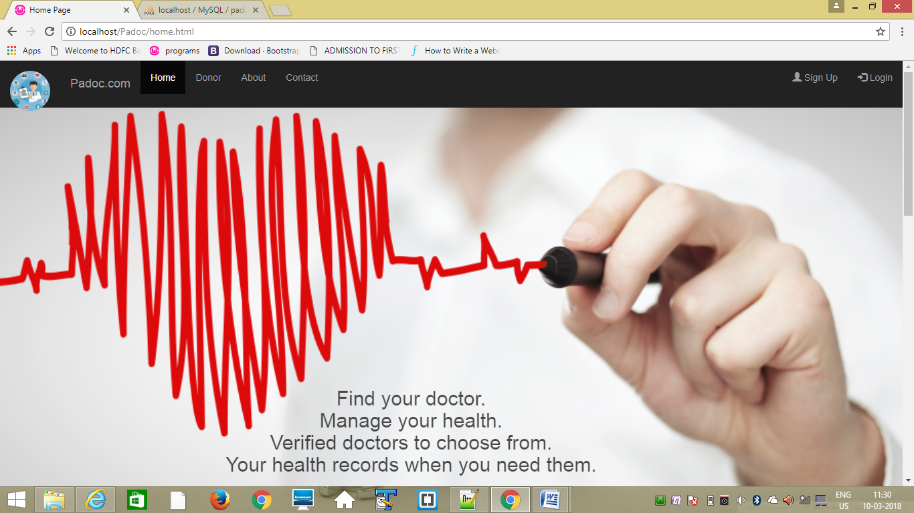

Log Modules:

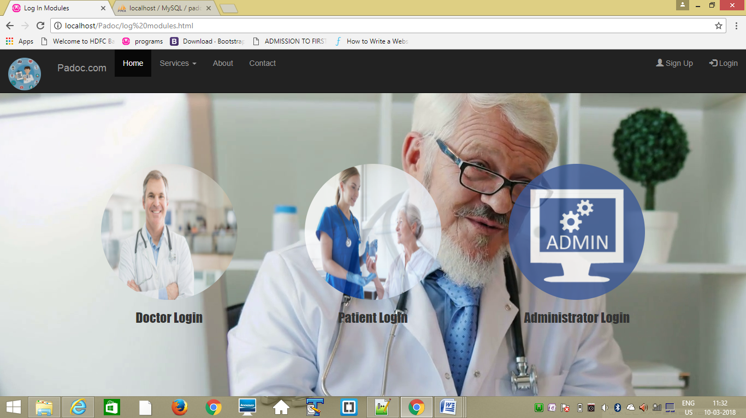

Doctor Login:

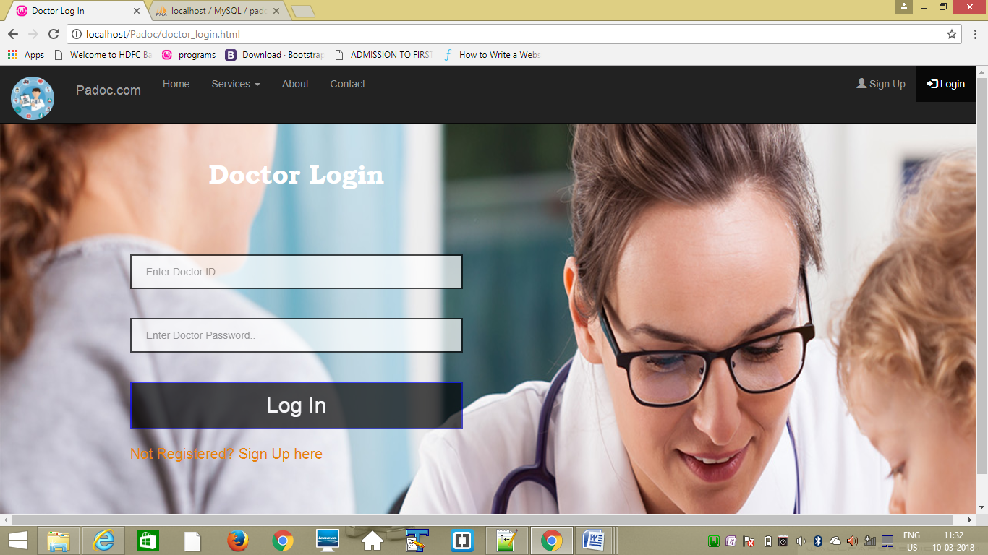

**Patient Login:**

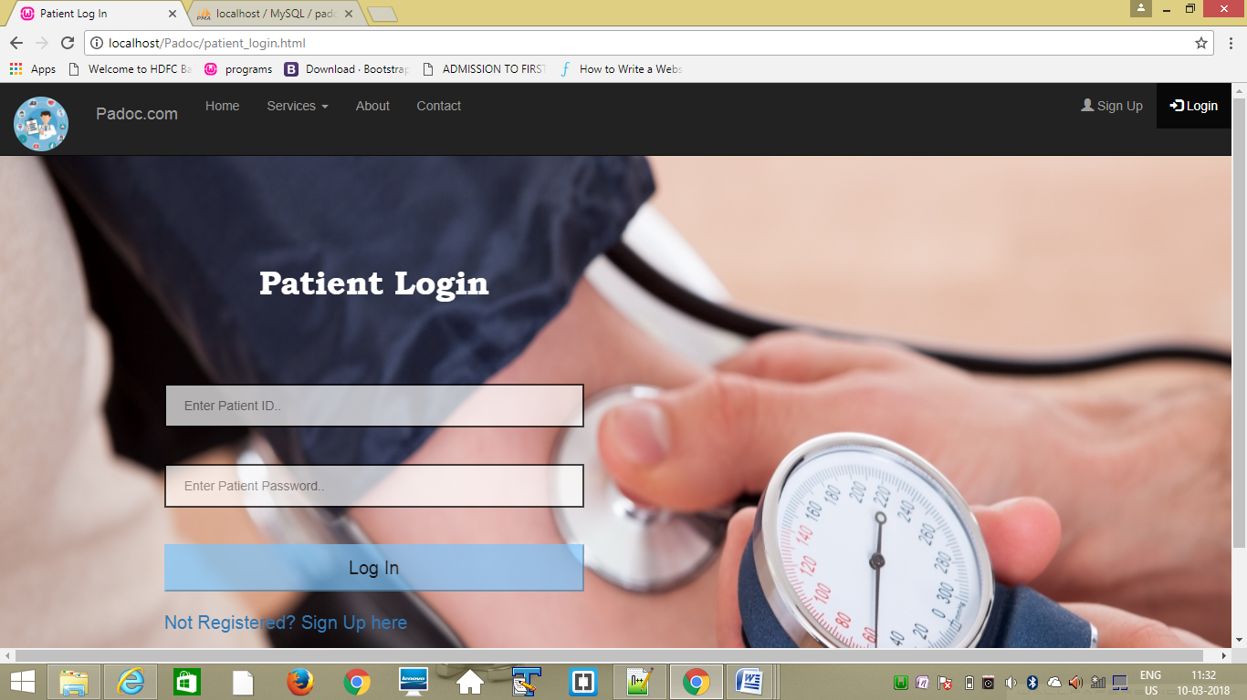

**Administrator Login:**

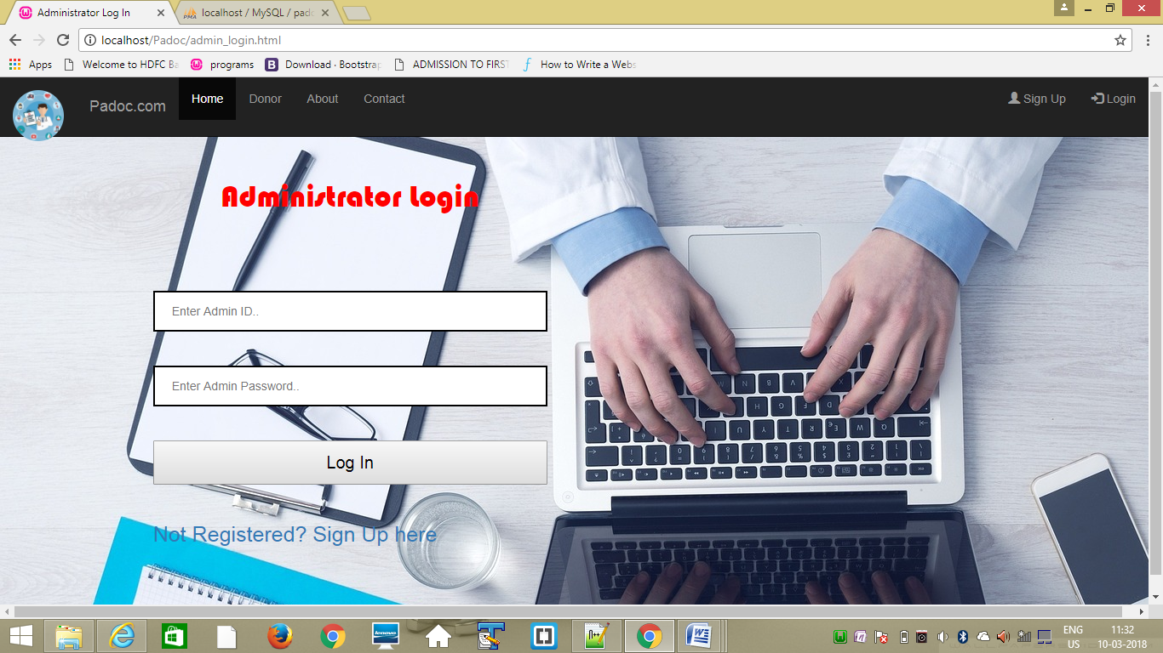

**Contact Us:**

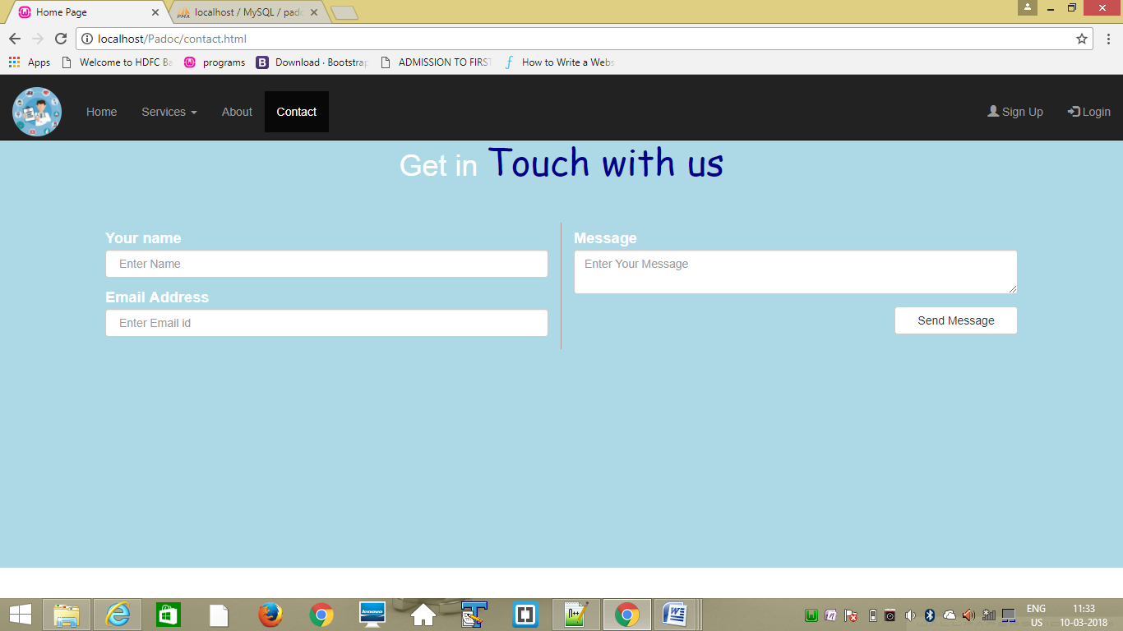

**Patient Sign Up Form:**

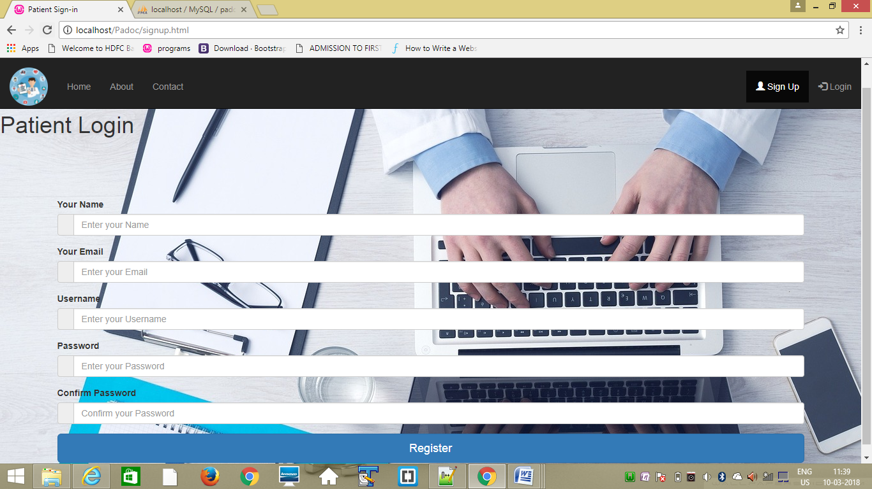

**Appointment booking Form:**

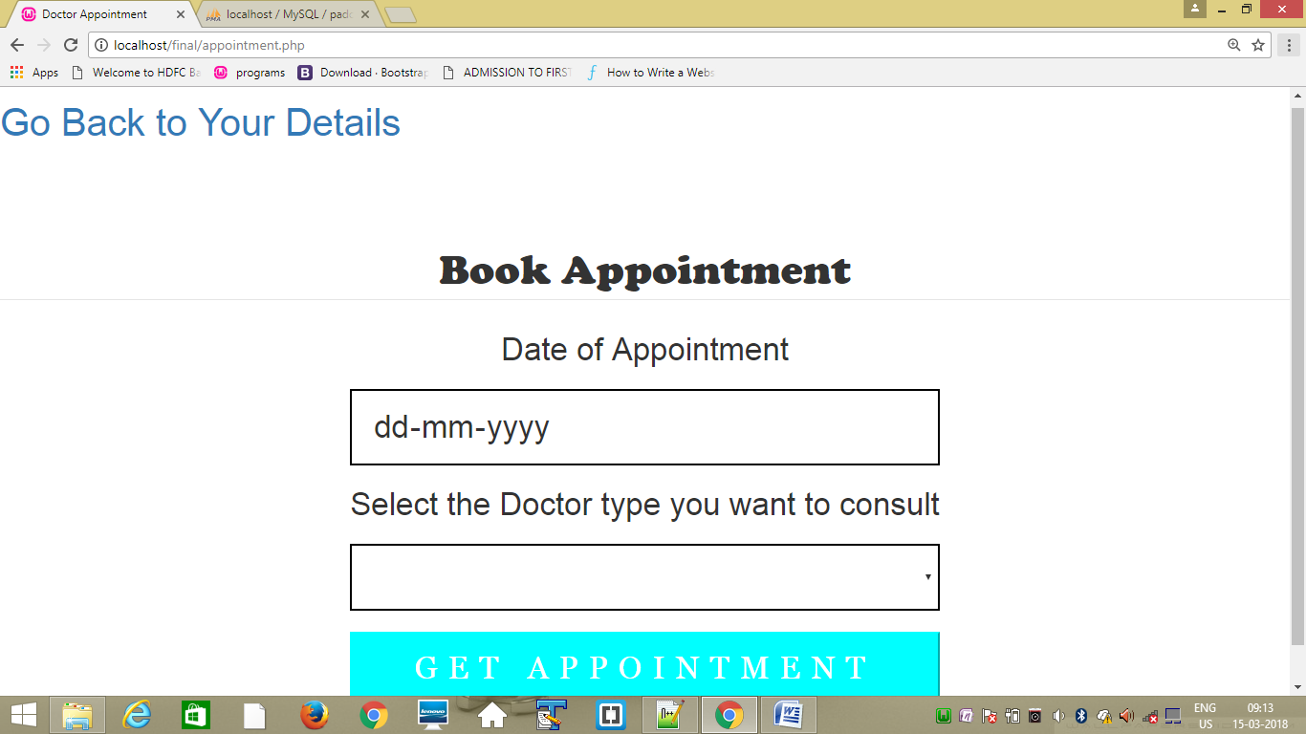

**Patient Details:**

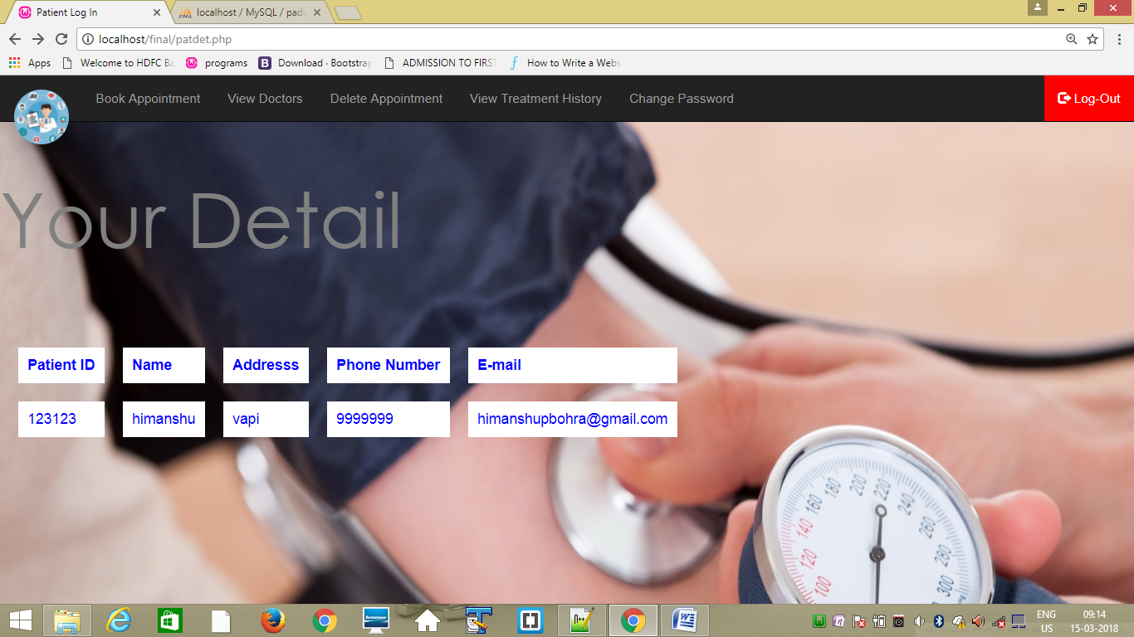

**Report:**

**Treatment History with Patient Detail Report:**

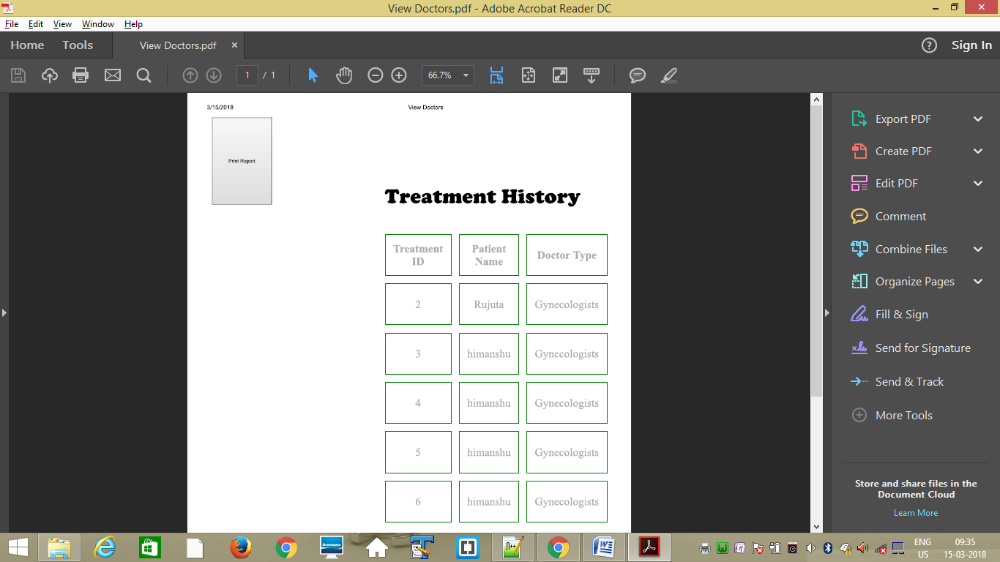

**Future Enhancement:**

The system will be reliable and efficient enough to handle the huge database.

1. Our system will be totally user friendly in nature.
2. The system will time saving and will avoid loss of data.
3. New system will be provided better security and easy access to the database.

**Conclusion:**

We conclude that it was a great working on this project. This project will be helpful when we will work in the educational fields where we can put in our project.

As a student we got theoretical as well as practical knowledge about the software and hardware subjects. Lastly, different software used has helped us in adding and improving practical knowledge about which we have studied.

**Bibliography:**

We have taken reference from the following:

1. Google
2. [www.youtube.com](http://www.youtube.com)
3. [www.W3school.com](http://www.W3school.com)
4. HTML and CSS by Jon Duckett
5. JAVASCRIPT and JQUERY by Jon Duckett